Host discovery technique:

Ping sweepd -- Icmp echo request is blocked by some operating system or firewalls such as window firefall by default block icmp echo request.
ARP scanning is effective in the same network. You must be coonect ot the network you are performing the arp scanning.
TCP SYN ping (stealth scan-half open scan)
UDP ping: it will be very effective when the host is not repponding to the icmp or tcp probes.
TCP ACK ping:
SYN ACK ping:
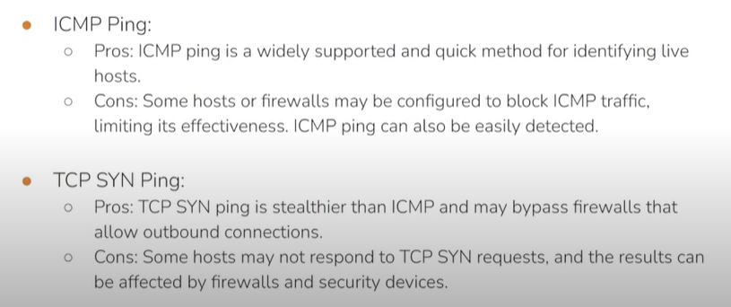
By default nmap send the syn packet to a particular port on the target to make it more efficientwe have o define more tcp port manually.

